Cervical Spine Evaluation and Clearance

Authors: Jake Zarah, MD, Saad B. Chaudhary, MD, Michael J. Vives, MD

- Background
  - Cervical spine injury is present in 2-6% of all trauma patients and can be a cause of major long term disability ¹
    - 50- 64% of spinal injuries involve the cervical spine²
    - The risk of having a cervical spine injury is greatest in patients with focal neurologic deficit, age greater than 50, high energy mechanism, and the presence of a head injury³
  - Critical to perform early evaluation and diagnosis in order to limit long term sequelae.
  - All trauma patients require a full work up for spinal cord injury
    - Complaints of pain or posterior midline tenderness in trauma patients require further work up.

- Definition
  - “Cervical spine clearance after blunt trauma is defined as accurately confirming the absence of a cervical spine injury”⁴

- Emergency Care
  - Field care
    - Patient must be extricated and immobilized at the accident scene to avoid further neurologic injury⁵.
      - Align head and neck with long axis of trunk⁶
      - Utilize a Cervical collar, sandbags, tape, and a spine board to immobilize
      - Maintain log roll precautions for transport
      - Use Kendrick Extrication device for patients enclosed in tight spaces⁷
    - Avoid cervical extension as it narrows the spinal canal, place neck in neutral alignment⁸
    - Pediatric patients require special attention, use a pediatric spine board with cut-out for occiput⁹, or elevate the trunk
    - Leave helmets and shoulder pads in place
    - Obtain a preliminary neurologic assessment in the field
  - ATLS Protocol
    - Developed by American College of Surgeons for reproducible, efficient methods of injury identification¹⁰
      - All trauma patients presumed to have cervical spine injury until proven otherwise
      - C-Collar can be removed in awake, alert, and sober patients with no neurologic abnormalities, cervical tenderness, and exhibit full, painless range of motion.
  - Pain, tenderness, neurologic abnormality or distracting injury warrant radiographic imaging
  - Resuscitation
    - Optimize perfusion (MAP > 85mm Hg), especially if a spinal cord injury is suspected
    - Evaluate for neurogenic shock
      - Loss of sympathetic outflow resulting in hypotension and bradycardia
      - Treated with fluid boluses and vasopressors¹¹.
    - Unresponsive patients
      - Maintain spine precautions until assessment completed or injury identified.

- Evaluation
  - History
    - Mechanism of Injury
    - Report of gross neurologic function in the field
    - History of transient motor or sensory changes
    - History of previous cervical spine abnormalities or trauma
  - Physical Examination
    - Musculoskeletal exam
      - Log roll patient using assistants to support head and neck as well as trunk
      - Inspect and palpate from occiput to sacrum and look for hemorrhage, abrasion, laceration, malalignment, or palpable gap in spinous processes
      - Range of motion testing only in asymptomatic patient
        - Turn head 45 degrees to each side; if painless, actively flex and extend the neck
    - Neurologic examination
      - Follow the American Spinal Cord Injury Association (ASIA) guidelines, the minimum exam that should be performed is listed in the chart below¹²
      - Maximum motor score is 100 points, maximum light touch and pin prick is 112 points
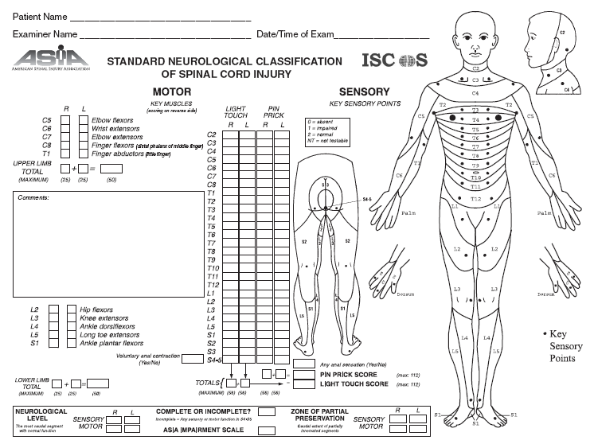

      - Other elements include¹:
        - Rectal exam: Asses for touch, pinprick, tone, voluntary contraction, and deep pressure sensation
        - Reflexes- in addition to normal upper and lower extremity reflexes:
          - Babinski- stroking plantar foot proximal lateral to distal medial (toes extend and splay w/ UMN lesion)
          - Oppenheim- UMN lesion- rubbing tibial crest proximal to distal (toes extend and splay w/ UMN lesion)
          - Cremasteric- stroking medial thigh proximal to distal (no scrotal motion w/ T12-L1 lesion )
          - Anal wink- stroking skin around anus (no anal sphincter contraction w/ S2-4 lesion)
          - Bulbocavernosis- tugging on foley or squeezing penis or clitoris (no anal sphincter contraction w/ S3-4 lesion or for patients in spinal shock!)

- Imaging
  - Who needs them?
    - NEXUS (National Emergency X-ray Utilization Study) Criteria¹³- if all criteria fulfilled, may remove collar without imaging. Found to be very sensitive for detecting cervical injury (99%), however very low specificity (12.9%)
      - No focal neurologic deficit
      - No posterior midline cervical tenderness
      - Normal alertness
      - No evidence of intoxication
      - No distracting pain
    - Canadian C-spine Rule^{14,15}- found to have better sensitivity and specificity (100% and 42% respectively), may reduce unnecessary imaging, however more complex
      - Must image if any of these high risk factors are present
        - age greater than 65
        - dangerous mechanism (fall greater than 3ft or 5 stairs, axial load to head, high sped mva, bicycle collision)
        - parasthesias in extremities
      - No imaging if the following low risk factors that allow safe assessment of motion are present
        - Simple rear end mva
        - Sitting position in emergency room
        - Ambulatory at any time
        - Delayed onset of neck pain
        - Absence of midline cervical tenderness
      - No imaging if able to rotate actively 45 degrees to each side
  - Modalities
    - Plain radiography
      - Lateral view 83% sensitive and 97% specific for detecting fracture¹⁶
      - Addition of open mouth view and AP increases sensitivity to nearly 100%¹⁶
        - Open mouth view essential for excluding C1 arch or C2 odontoid process fractures
        - AP view assesses alignment of uncovertebral joints and spinous processes
        - Oblique views can be used to assess facet joints, pedicles and lateral mass, especially at cervicothoracic junction
      - If unable to visualize the cervico-thoracic junction on the lateral, obtain a swimmers lateral view or a CT scan
      - For patients with normal x-rays and persistent cervical tenderness and pain, obtain a CT scan
      - Flexion-Extension views are not useful in the acute setting¹⁷
        - Pain and discomfort precludes adequate motion to assess for ligamentous injuries
        - Only perform on alert patients under supervision as flexion with an occult ligamentous injury may precipitate neurologic injury¹
    - CT
      - Useful for determining the presence and extent of osseous injury (superior than MRI)
      - In blunt trauma patients, CT detects 99.3% of cervical spine fractures¹⁸
      - Injuries in the transverse plane may be missed on axial cuts, i.e. odontoid fractures
        - Must obtain coronal and sagittal reconstructions
    - MRI
      - Indicated for neurologic deficits, ligamentous injuries
      - Superior to CT for demonstrating spinal cord pathology, intervertebral disc herniation and ligamentous disruption
      - Primary use for initial cervical clearance limited
        - Highly sensitive images show muscular and soft tissue images that do not necessarily correlate with clinical instability¹⁹
        - Not necessary if initial screening CT is negative and patient demonstrates no neurologic abnormalities

- Algorithm
    - Anderson et al⁴ classified patients into 4 groups that dictate when to use which modalities
      - Asymptomatic patient
        - Use Nexus criteria or Canadian C-spine rules to determine necessity of imaging.
          - If negative, clear without imaging
      - Temporarily Not Assessable- due to intoxication or distracting injury
        - Maintain in collar until assessable
        - If urgent or severely injured, manage as obtunded
      - Symptomatic patient
        - AP/Lateral/Odontoid plain x-rays
          - Flexion-extension views in subacute setting (2 weeks)¹⁷ if symptoms persist
        - CT if x-rays inadequate or if patient undergoing CT for other reasons
        - MRI for patient with spinal cord injury, progressive neurologic deterioration or suspected ligamentous injury
      - Obtunded patient
        - CT has evolved to be first line modality in obtunded patient in trauma setting
        - If negative, Anderson supports discontinuing cervical collar
          - MRI may find abnormalities with a negative CT, however these abnormalities are not likely to be clinically significant²⁰
        - American College of Radiology advocates both CT and MRI for clearance of the obtunded patient
        - No clear consensus currently exists

References
1. Buckholtz RW et al. Rockwood and Greens Fractures in Adults. Seventh Edition. 2010. Chapter 41- Principles of Spine Trauma Care.
2. Tator CH, Duncan EG, Edmonds VE, et al. Neurological recover, mortality and length of stay after acute spinal cord injury associated with changes in managament. Paraplegia 1995; 33(5): 254-262
3. Blackmore CC, Emerson SS, Mann FA, et al. Cervical spine imaging in patients with trauma: determination of fracture risk to optimize use. Radilogy 1999; 211(3) 759-765
4. Anderson PA et al. Clearing the Cervical Spine in the Blunt Trauma Patient. JAAOS. March 2010, Vol18: 149-159
5. Podolsky S, Baraff LJ, Simon RR, et al. Efficacy of cervical spine immobilization methods. J Trauma 1983; 23(6):461-5
6. Banta G, ed. Emergency Care and Transportation of the Sick and Injured. Menasha WI: American Academy of Orthopaedic Surgeons, 1987
7. Winterberger , Jacomet H, Zafren K, et al. The use of extrication devices in crevasses accidents: official statement of the International Commission for Mountain emergency Medicine and the Terrestrial Rescue c=Commission of the International Commission for Alpine Rescue intended for physicians, paramedics and mountain rescuers. Wilderness Envrion Med 2008; 19 (2) 108-110
8. Ching RP, Warson NA, Carter JW et al. The effect of post injury spinal position on canal occlusion in the cervical spine burst fracture model. Spine 1997; 22(15):1710-1715
9. Apple DF Jr, Anson CA, Hunter JD, et al. Spinal cord injury in youth. Clin Pediatr (Phila) 1995; 34(2):90-95
10. American College of Surgeons. Advanced trauma life support student manual. Chicago: Author 1989
11. Consortium for Spinal Cord Medicine. Early acute management in adults with spinal cord injury: a clinical practice guideline for health care professionals. J Spinal Cord Med 2008; 31(4): 403-479
12. American Spinal Cord Injury Association. International Standards for neurological classification of spinal injury. Atlanta Ga: Author 2008
13. Hoffman JR, Mower WR, Wolfson AB, et al. Validity of a set of clinical criteria to rule out injury to the cervical spine in patients with blunt trauma. National Emergency X-Radiography Utilization Study Group. N Engl J Med 2000; 343(2):94-99
14. Stiel IG, Clement CM, McKnight RD, et al. The Canadian C-spine rule versus the NEXUS low-risk criteria in patients with trauma. N Engl J Med 200; 349 (26):2510-2518
15. Stiel IG, Wells GA, Vandemheem KL et al. The Canadian C-Spine rule for radiography in alert and stable trauma patients. JAMA 2001; 286(15):1841-1848
16. MacDonald RL, Schwartz ML, Mirich D, et al. Diagnosis of Cervical Soine injuries in motor vehicle crash victims: how many x-rays are enough? J Trauma 1990; 30(4): 392-397
17. Daffner RH, Hackney DB. ACR: Appropriateness Criteria on suspected spine trauma. J Amer Coll Radiol 2007; 4: 762-775
18. Brown CV, Antevil JL, Sise MJ, Sack DI. Spiral computed tomography for the diagnosis of cervical, thoracic and lumbar spine fractures: Its time has come. J Trauma 2005; 58: 890-895
19. Thuret S, Moon LD, Gage FH: Therapeutic Interventions after spinal cord injury. Nat Rev Neurosci 2006:7(8): 628-643
20. Hogan GJ, Mirvis SE, Shanmuganathan K, Scalea TM: Exclusion of unstable cervical spine injury in obtunded patients with blunt trauma: Is MRI needed when mutli-detector row CT findings are normal? Radiology 2005; 237: 106-113

