Patellofemoral disorders

Description
Anterior knee pain may be found with patellar instability (subluxation or complete dislocation of the patella out of the trochlear groove) or patellofemoral arthrosis. It may also have no objectively defined cause, in which case the label “patellofemoral pain syndrome” is applied. Many patients with patellofemoral pain syndrome improve with no treatment. Patellar instability may be treated with muscle strengthening therapy or braces; at times, however, surgery is needed.

Structure and Function
The patellofemoral joint is formed by the patella and the anterior surface of the distal femur, an area called the trochlear groove.

The patella is a sesamoid bone that is embedded within the quadriceps tendon and serves to increase the mechanical advantage of the quadriceps muscle. The undersurface of the patella is composed of two main facets, lateral and medial. The lateral facet is longer and less steep, matching the geometry of the lateral aspect of the trochlea.

Figure 1: A sunrise view of the patella, showing the patella sitting within the trochlear groove of the femur. (from http://www.wikiradiography.net/page/the+skyline+patella+projection)
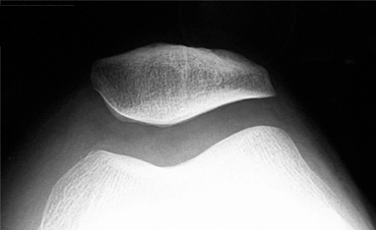

Stability of the patella in the patellofemoral joint is dependent on the trochlear morphology as well as the alignment of the tibia relative to the femur, as a sharp angulation of the pull of the quadriceps relative to the tibial tubercle will create a lateral vector pulling the patella out of the groove. This can be assessed by two measurements: the angle between the quadriceps and the infrapatellar ligament, so called Q angle and the tibial tubercle to trochlear groove (TT-TG ) distance (Figure 2).

FIGURE 2: Q-angle: The Q angle is defined by a line from the anterior-superior iliac spine through the midpoint of the patella and another line from the tibial tuberosity through the midpoint of the patella. The line from the anterior-superior iliac spine through the midpoint of the patella represents the pull of the quadriceps. This force vector, shown by the green line in the enlarged view, can be resolved into a superior force (red line) and laterally-directed force (blue line). Thus, the greater the Q angle, the greater force pulling the patella laterally, out of its healthy position in the trochlea.
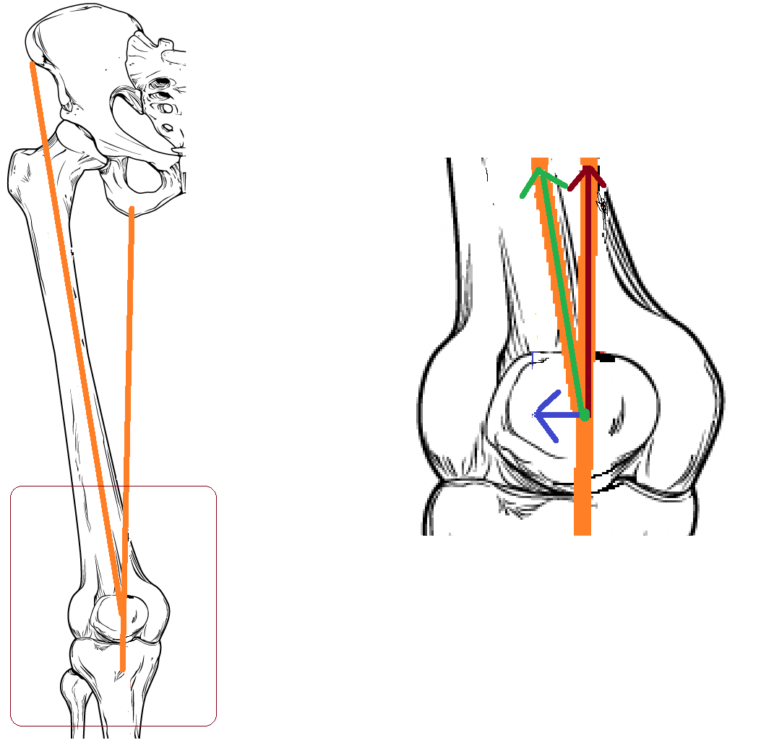

Figure 3: The tibial tubercle to trochlear groove distance is defined by 2 slices of a CT scan. First, the base of the trochlea is defined, and line is drawn through it, down to the bottom on the scan. The position of this (red) line is identified by the star on a line denoting medial-to-lateral distance (shown in blue). On a more distal slice, the tibial tubercle is identified, and a line is drawn through it down to the bottom of the scan as well, shown here in green, and the position is also identified. The distance between these two lines is the tibial tubercle to trochlear groove distance. (Redrawn from a case courtesy of Dr. Ayush Goel, Radiopaedia.org, rID: 28749)
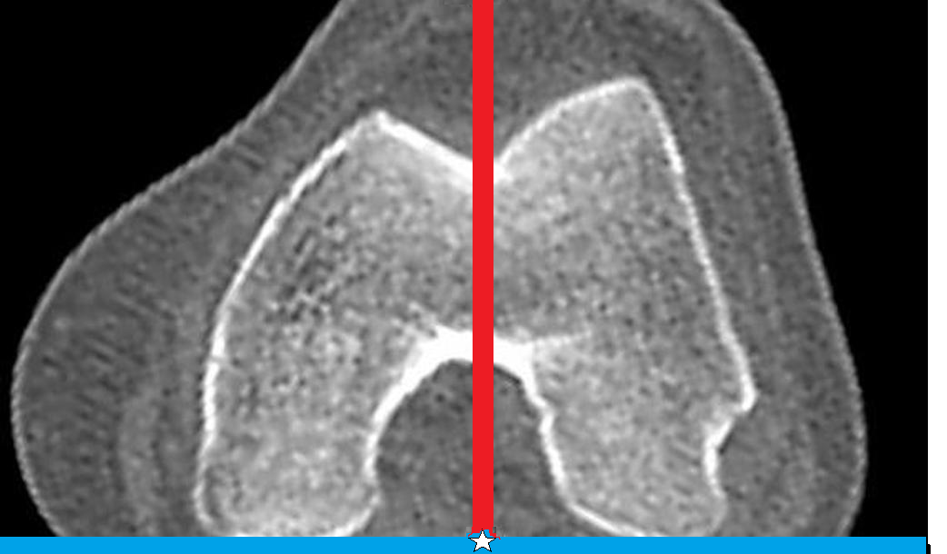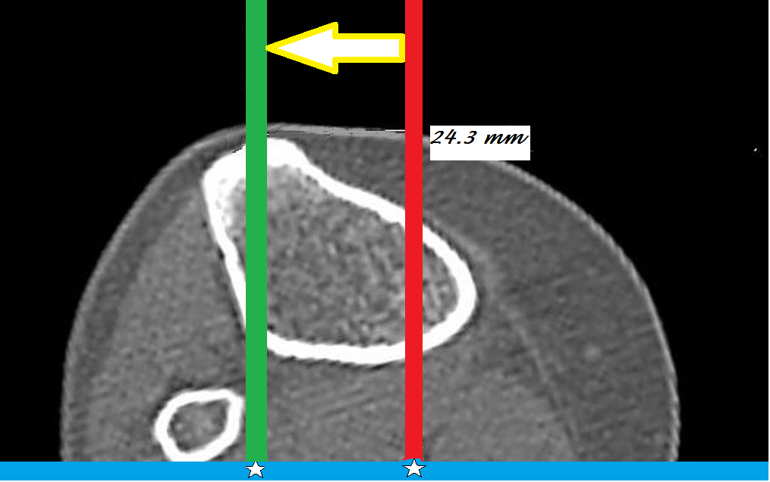

Additional static stability is provided by the lateral retinaculum, medial retinaculum, medial patellofemoral ligament, and medial patella-tibial ligament.

The vastus medialis obliquus provides dynamic stability, actively pulling the patella medially, to keep it located within the joint (Figure 4).

Figure 4: As shown, the pull of the vastus medialis obliquus (red line) has a medially-directed component (white arrow), which tends to stabilize the patella. Weakness or atrophy of this muscle is thus associated with patellofemoral disorders.
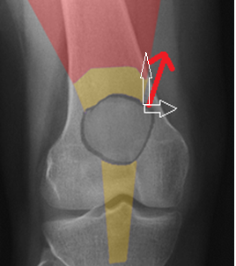

During initial knee flexion (<30 degrees), the major restraints to lateral translation and dislocation are the soft tissue structures; beyond 30 degrees, the bony structures are the primary determinants of stability.

The medial patellofemoral ligament is the primary soft tissue restraint against lateral translation of the patella. This ligament is torn when there is excessive lateral translation of the patella.

In cases of so called patella alta, a longer than normal patellar tendon allows the patella to rest more proximally. As a result, the patella does not enter the trochlear groove until higher-than-normal levels of knee flexion have occurred. In patients with recurrent instability, trochlear dysplasia has been noted to be present in up to 96% of patients.

Patient Presentation
A thorough patient history and physical examination are critical components in diagnosing patellofemoral pain syndrome and patellar instability. Patients will report pain and possibly swelling in their knee with increasing intensity such as climbing or descending stairs, squatting, running, jumping, or "cutting" during sports activities.

In some cases of patellofemoral pain syndrome, patients will commonly report feeling pain “behind,” “underneath,” or “around” the patella. Many patients will not experience swelling with patellofemoral pain syndrome; however, patients will note stiffness, particularly when the knee is flexed, as well as potentially “popping” or “catching” sensations.

Patients may also note overall weakness in their leg as well as a feeling that their knee might “give way” again in cases of patellar instability. Discoloration medially and pain along the medial aspect of the knee are commonly seen. The number of prior identifiable dislocations and subluxation episodes for the patient as well as any history of ligamentous laxity or dislocation of family members must be noted.

Physical examination should note alignment and range of motion; the presence or absence of tenderness should be noted as well.

Examination maneuvers are shown in the figures.

Figure: NEED CLINICAL PHOTOS Patellar glide: With the patient lying in the supine position and the knee extended, the patella is grasped and translated medially, and displacement is measured in quadrants. Displacement of less than one quadrant medially indicates tightness of the lateral structures while hypermobility is indicated by displacement of more than three quadrants.
NEED CLINICAL PHOTOS Patellar tilt: With patient lying in the supine position and the knee extended, grasp the patella laterally and medially with the thumb and forefinger, respectively. Lift your thumb to raise the lateral side of the patella. The patella should “tilt” back to neutral (with a line through the medial and lateral facets parallel to the exam table).
NEED CLINICAL PHOTOS Patellar inhibition: in the presence of arthrosis, a patient will not want to load the damaged area, and will actually shut off (“inhibit”) the quadriceps if that muscle is forcing the contact. Because a different point of the patella articulates in different degrees of flexion, the best way to assess patellar inhibition is to have the patient actively extend the knee against resistance at 30, 45, 60 and 90 degrees of flexion. Subtle relative weakness suggests inhibition and in turn arthrosis of the patellofemoral joint.
NEED CLINICAL PHOTOS Patellar apprehension: the examiner tries to push the patella out of the trochlea with the knee extended. A reported sense of impending dislocation (“apprehension”) is a positive test.
NEED CLINICAL PHOTOS (showing knee flexed and then extended) Patellar tracking (J-sign): The examiners scrutinizes the position of the patella when the knee flexes from full extension to full flexion. If the soft tissues are lax, the patella will be situated in a far lateral position in extension but not in flexion, as in flexion the bony anatomy holds the patella. Thus, if the soft tissues are lax, the patella will follow a “J” or “L” course when the knee is flexed.

Most patella dislocations occur laterally; therefore, the lateral patellar apprehension test represents the best test for determining patellar instability.
The quadriceps and patellar tendons should be palpated to detect tendinosis.

Additionally, a Lachman’s test, pivot shift, anterior and posterior drawer test, dial test, and varus/valgus stress test should be performed to rule out other injuries.

Objective Evidence
For patients with patellofemoral pain syndrome, the diagnosis is primarily a clinical diagnosis and can be made without radiographic imaging; however, x-rays will commonly be ordered to rule out damage to the structure of the knee and to the tissues that connect to it.

In cases of suspected patella instability, anteroposterior and posteroanterior 45° weight bearing views should be obtained to examine any abnormal anatomy, particularly current presence of dislocation. Lateral radiographs should be ordered to examine patella height, trochlear dysplasia and patellar tilt.

The sunrise view (Figure #) can evaluate for lateral subluxation and patellar tilt.

Figure #: In this sunrise view, the normal patellofemoral joint is shown on the x-ray, with the red line outlining patellar tilt (rotation of medial side up) as well as lateral subluxation. Both contribute to excess compression laterally.
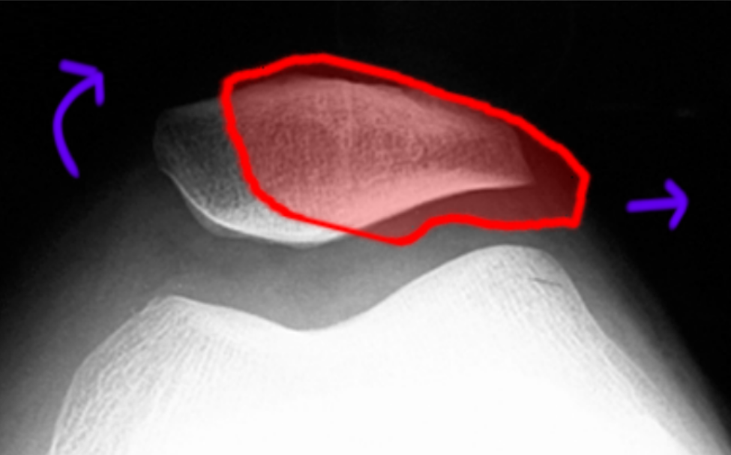

CT scans provide valuable axial information allowing evaluation of the anterior tubercle to trochlear groove distance. The mean tibial tubercle to trochlear groove distance has been noted to be 9 mm while a tibial tubercle to trochlear groove distance of 20 mm or more has a 90% association with patellar instability. CT is more reliable than MRI for this assessment.

MRI is valuable in assessing for cartilage/osteochondral injury as well as soft tissue structures of the knee. MRI will help evaluate any articular cartilage damage on the medial facet of the patella and bone bruising of the lateral femoral condyle.

Figure #: MRI of an acute patellar dislocation. Edema is seen in both the patella and the lateral condyle, reflecting the impact (“kissing contusion”) between these bones when the patella dislocated laterally. The red lightning bolt points to the disrupted medial patellofemoral ligament, whereas the lateral ligament is intact (blue star). (Case courtesy of Dr. Hector RiveraMelo, Radiopaedia.org, rID: 27014)
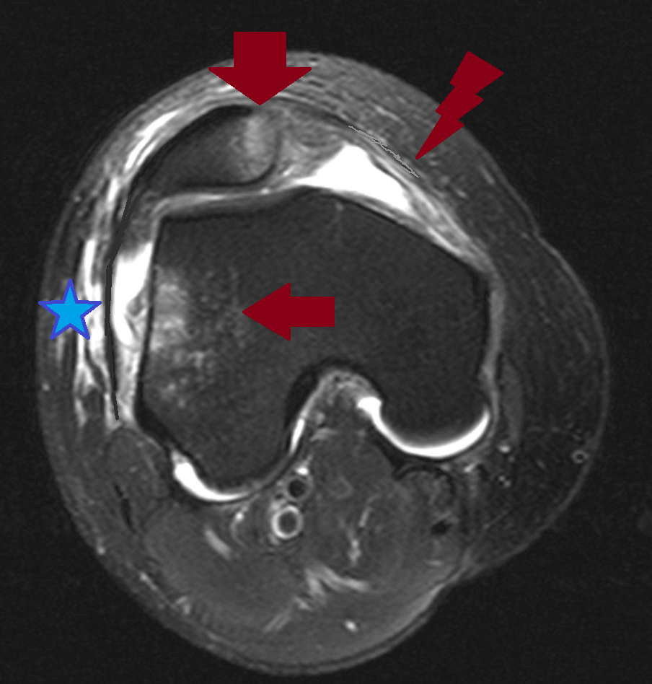

Epidemiology
Anterior knee pain is the most common knee diagnosis in sports medicine centers and among runners. Up to 11% of musculoskeletal complaints in the outpatient setting are caused by anterior knee pain, most commonly patellofemoral pain syndrome, and the incidence of patellofemoral pain syndrome in runners is between 16% and 25%.

The majority of patellar instability occurs in young, active individuals with an incidence of 1 per 1000 people. Overall, patellar dislocations represent approximately 3% of all knee injuries. Females are more likely to have patellar dislocations than men and the most commonly affected age group is individual’s ages 10 to 16 years old. Patellar instability is commonly traumatic in nature due to either contact or non-contact mechanisms; however, patients with patellar malalignment may experience frequent low-energy patellar dislocations.

Differential Diagnosis
Anterior knee pain may be due to instability (with or without an overt history of dislocation); it may be due to patellofemoral arthrosis (with or without radiographic confirmation); it may be due to tendinosis on either side of the patella; or it may have no known causes.

At times, patellar dislocations reduce spontaneously, such that the patient may not be aware that the patella dislocated other than feeling a shift in their knee.

Patients may report buckling due to patellar inhibition, but of course true ligamentous laxity must be excluded before that diagnosis is credited.

Red Flags

Gross laxity of the patellofemoral stabilizers may suggest a connective tissue disorder, such as Ehlers-Danlos syndrome.

Incomplete passive motion after a patellofemoral dislocation suggests a loose body within the knee.

Treatment Options and Outcomes
For patients diagnosed with patellofemoral pain syndrome, a comprehensive rehabilitation program is the first line of treatment. Rehabilitation programs should include modification or cessation of activities as well as physical therapy.

A knee sleeve, splint, or taping may be used as well. This may help hold the patella within the trochlea. Alternatively, these may help simply by serving to remind the patient to avoid full flexion.

Recovery from patellofemoral pain syndrome can take longer than most patients anticipate.
Patients with pain but without a correctable anatomic lesion are rarely helped (and may be hurt) by surgery.

Patients sustaining their first dislocation can be treated with a brace. However, even in first time dislocations (especially if there is a large hematoma that raises concern for osteochondral injury) – an MRI is useful. This test can detect loose bodies and assess for any damage to the ligaments and cartilage.

After a first-time dislocation, physical therapy (PT) is started 1-2 weeks after the dislocation, to help achieve normal range of motion and strength and is continued for 2-3 months. In some cases, 4-5 months of PT is necessary in order for athletes to return to their pre-injury level of activity.

In cases of recurrent instability, operative treatment is frequently recommended. Operative treatment is based upon the patient’s anatomy and the spectrum of injury. It may consist of either an isolated soft tissue procedure or a bony realignment procedure or both.

The most common procedure is reconstruction of the medial patellofemoral ligament with an autograft (hamstring tendon) or allograft. Although less common, repair of the medial patellofemoral ligament is possible in some patients who seek treatment promptly and have a bony avulsion of the ligament from the medial aspect of the patella.

In patients presenting with recurrent instability and bony malalignment, a bony procedure or realignment surgery is commonly performed either in isolation or concomitantly with a soft tissue procedure. If the tibial tubercle to trochlear groove distance is greater than 20 mm, an osteotomy or a tibial tubercle transfer is performed. The goal of this procedure is to realign the patellar tendon to track more medially and reduce the tibial tubercle to trochlear groove closer to the mean of 9 mm.

For patients with an open growth plate, surgeons will commonly perform an isolated soft tissue procedure and then perform the realignment surgery after closure of the growth plates to prevent further cartilage damage underneath the kneecap as well as to prevent arthritis from developing.

In cases of extreme dysplasia, trochleolpasty may be performed; however, this technique has not gained widespread acceptance in the United States.

For either procedure, rehabilitation typically lasts 4-6 months post-surgery and final recovery and return to sports is not usually achieved until after 6 months from reconstruction (when full range of motion, stability, and strength have been restored).

Following completion of a thorough rehabilitation program, patellofemoral pain syndrome commonly resolves–but to prevent recurrence, appropriate conditioning of the muscles around the knee, particularly the quadriceps and the hamstrings is essential.

After an initial dislocation, the ligaments are stretched from the injury; therefore, patients are at an increased risk for either a recurrent subluxation or dislocation. The incidence of recurrent instability following conservative treatment has been noted to be between 15% and 44%. After a second dislocation, the risk of recurrence increases to over 50% and in younger patients (less than 25 years of age, particularly those with open growth plates) the risk of recurrence after a second dislocation has been noted to be as high as 70%.

Following operative treatment, the success rate for stabilization has been noted to be as high as 85% - 90% for both soft tissue and bony procedures.

Risk Factors and Prevention
Risk factors for patellofemoral pain syndrome include females and young adults as the condition is commonly referred to as “runner’s knee”, due to the high occurrence in athletes. Additionally, malalignment of the kneecap and overuse from vigorous athletics or training are also significant risk factors.

For patellar instability, risk factors include young age (under the age of 25 with a peak incidence between ages 10-16 years old) and open growth plates (this is particularly a risk factor for patients after primary dislocation). A prior history or patellar dislocation or subluxation represents a significant risk factor as up to 44% of patients treated conservatively may experience a second instability episode.

Key Terms
Patellar dislocation, Patellar subluxation, medial patellofemoral ligament injury, Q-angle, tibial tubercle to trochlear groove distance, trochlear dysplasia, patella alta

Skills
Perform Patellar, tilt, apprehension and inhibition tests. Assess Q angle on imaging.

